**PRACTICAL NO:-10**

**a. Creating JSON**

**CODE:-**

import json

dict={

    "name":"Rohit",

    "age":36,

    "country":"India",

    "IPL_team":"Mumbai Indians",

    "highest_score":264

    }

print(f"Python dictionary is \n {dict}")

print("\ntype now is",type(dict))

json_string=json.dumps(dict)

print(f"Python dictionary in json is \n {json_string}")

print("\ntype now is",type(json_string))

file_name="python_json_dump.json"

with open(file_name,"a") as a:

    a.write(json_string)

print(f"JSON data saved to '{file_name}' using string method.")

**OUTPUT:-**

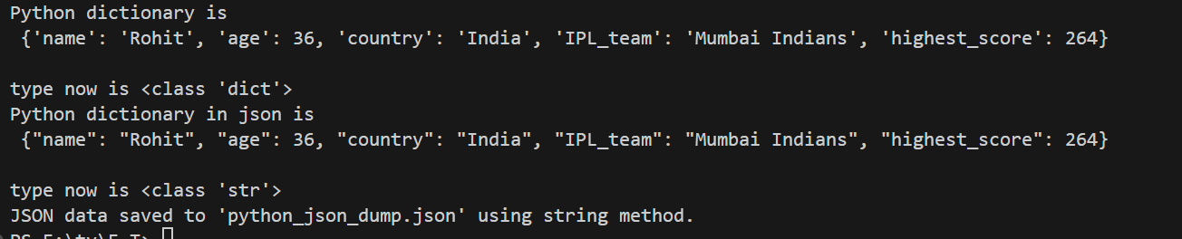

**Text file:-**



**b. Parsing JSON**

**CODE:-**

import json

try:

        file_name="python_json_dump.json"

        with open(file_name, 'r') as json_file:

            player_data = json.load(json_file)

        print("\nJSON Data Successfully Parsed into a Python Dictionary")

        print(f"Type of loaded data: {type(player_data)}")

        print(f"Player Name: {player_data['name']}")

        print(f"Player Age: {player_data['age']}")

        print(f"IPL Team: {player_data['IPL_team']}")

except e:

      print(e)

**OUTPUT:-**

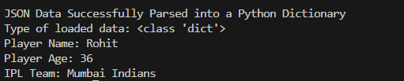

**c. Persisting JSON**

**CODE:-**

import json

dict={

    "name":"Rohit",

    "age":36,

    "country":"India",

    "IPL_team":"Mumbai Indians",

    "highest_score":264

    }

from pymongo import MongoClient

client = MongoClient('mongodb://localhost:27017/')

db = client['data=base']

collection = db['cric_info']

result = collection.insert_one(dict)

print(f"Data persisted to MongoDB. Document ID: {result.inserted_id}")

client.close()

**OUTPUT:-**



**d. Export MongoDB to JSON.**

**Command:**

**mongoexport --db mydatabase --collection users --out users_export.json**



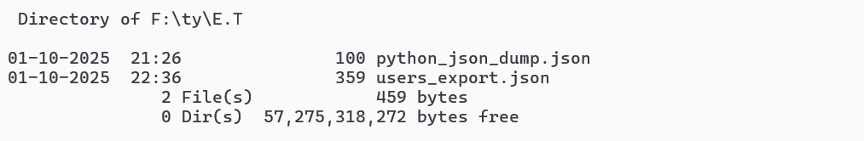

**e. Write a MongoDB query to delete JSON object from MongoDB.**

